# Preface

This packet contains information related to the development of the Real-time Network Analysis system (ReTiNA). This system was developed for use with the Cyberstorm hacking competition as a part of the Senior Capstone 2010 class at Louisiana Tech University. The goal of ReTiNA is to provide users with a real-time situational awareness of network activity, including active network nodes and network attack information. This system was built by the Cyberstorm Real-time Network Attack and Node Detection team, led by Michael King. The other members of this time were Delvin Jackson, Ryan Lockwood, Ryan Rollins, and Daniel Sawyer, with advisors Justin Poole and Dr. Jean Gourd.

This packet first contains a timeline for the project, followed by the task trackers for each iteration of the project. Finally, the packet contains the Software Requirements Specification document, which covers the system features and provides an overview of the development cycle.

# Table of Contents

Preface i

Table of Contents ii

Timeline 1

Iteration Tracking 2

Software Requirements Specification Document 7

# List of Tables

Figure 1. ReTiNA Gantt Chart 1

Figure 2. Iteration 1 Task Tracker 2

Figure 3. Iteration 2 Task Tracker 3

Figure 4. Iteration 3 Task Tracker 4

Figure 5. Iteration 4 Task Tracker 5

Figure 6. Issue Tracker 6

# Timeline

Meeting the deadline was the most pressing constraint of this project. Our system had to be working for the Cyberstorm competition where it would actually be used and presented before an audience. As such, time management was a prime aspect of the project's managements. Figure 1 shows a Gantt chart for this project that gives a broad overview of the project's scheduling. Due to the modular approach used to develop this system, the dependencies in the Gantt chart can be difficult to follow. Appendix A of the Software Requirements Specification document contains a PERT chart where the dependencies can be more easily tracked.

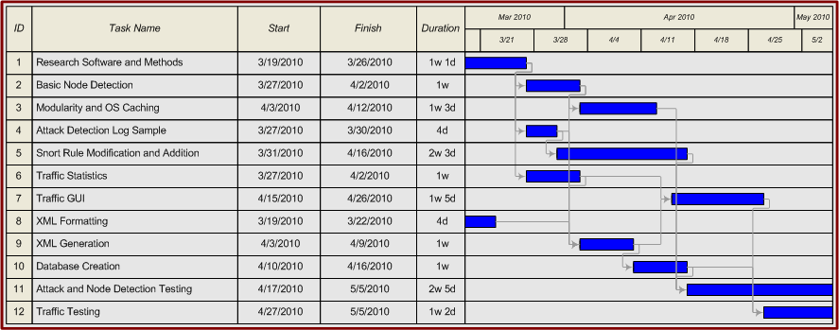

Figure 1. ReTiNA Gantt Chart

# Iteration Tracking

The Cyberstorm project used an iterative software development module to create weekly milestones toward completion. The ReTiNA system used a modular development method as well due to the separate modules required of our system. The modules were split into Node Detection, Attack Detection, Communications Interface, and Traffic Statistics. Each module was developed independently by different team members, with members helping on other's modules if they had slack time. To fit this in the iterative model used for the entire project, each module was expected to meet certain milestones within their iteration.

Figures 2,3,4 & 5 show our Iteration Task Trackers for each of the week-long project iterations. Figure 6 shows the Issue Tracker for what should have been just a testing phase, however, there was still some development occurring in this phase on the Traffic Statistics module due to scope creep. A detailed explanation of the Task and Issue Trackers and the ReTiNA development cycle can be found in the Software Requirements Specification document.

|  |  |  |  |  |  |
| --- | --- | --- | --- | --- | --- |
| **CS Capstone Task Tracker It. 1** | | | | | |
| **Real Time Network Visualization Team** | | | | | |
|  |  |  |  |  |  |
| **T-#** | **Tasks** | **Due Date** | **Distribution Info** | **Status** | **Remarks** |
| **1.00** | XML Documentation | 22–Mar–10 | Full Team | **Complete** | XML Format for Front end team |
| **2.00** | Software Installation | 24–Mar–10 | Full Team | **Complete** | Installation of Snort, tcpdump, etc |
| **3.00** | Simple Log Parsing | 25–Mar–10 | Lockwood, King | **Working** | Pull IPs, simple attack tags from logs |
| **4.00** | XML outputting | 26-Mar-10 | Jackson | **Complete** | Convert Parse output to XML |
| **5.00** | Documentation | 26-Mar-10 | King | **Complete** | Compile SRS info, pamphlet form |

Figure 2. Iteration 1 Task Tracker

|  |  |  |  |  |  |  |  |
| --- | --- | --- | --- | --- | --- | --- | --- |
| **CS Capstone Task Tracker It. 2** | | | | | | | |
| **Real Time Network Visualization Team** | | | | | | | |
|  | |  |
| **T-#** | | **Tasks** | | **Due Date** | **Distribution Info** | **Status** | **Remarks** |
| **1.00** | | XML Documentation, Node detection | | 29-Mar-10 | King | **Complete** | Establish XML format, send to front-end and Sawyer |
| **2.00** | | Traffic Monitor - Manipulating Snort Rules | | 30-Mar-10 | Rollins, Lockwood | **Complete** | Learn how to add/modify Snort rules and what it picks up by default |
| **3.00** | | Node detection - Input config | | 30-Mar-10 | King | **Complete** | Complete config file and IP address input |
| **4.00** | | XML Generation, Node detection | | 31-Mar-10 | Jackson | **Complete** | Generate XML from my Node detection output |
| **5.00** | | Node detection- Basic Complete | | 2-Apr-10 | King | **Working** | 1st Revision of Node detection, should have all basic functionality |
| **6.00** | | Traffic Monitor - 1st Revision | | 2-Apr-10 | Rollins, Lockwood | **Working** | 1st Revision of Traffic Monitor, parse snort logs, generate needed output, basic attack types |

Figure 3. Iteration 2 Task Tracker

|  |  |  |  |  |  |  |  |
| --- | --- | --- | --- | --- | --- | --- | --- |
| **CS Capstone Task Tracker It. 2** | | | | | | | |
| **Real Time Network Visualization Team** | | | | | | | |
|  | |  |
| **T-#** | | **Tasks** | | **Due Date** | **Distribution Info** | **Status** | **Remarks** |
| **1.00** | | XML Documentation, Node detection | | 29-Mar-10 | King | **Complete** | Establish XML format, send to front-end and Sawyer |
| **2.00** | | Traffic Monitor - Manipulating Snort Rules | | 30-Mar-10 | Rollins, Lockwood | **Complete** | Learn how to add/modify Snort rules and what it picks up by default |
| **3.00** | | Node detection - Input config | | 30-Mar-10 | King | **Complete** | Complete config file and IP address input |
| **4.00** | | XML Generation, Node detection | | 31-Mar-10 | Jackson | **Complete** | Generate XML from my Node detection output |
| **5.00** | | Node detection- Basic Complete | | 2-Apr-10 | King | **Working** | 1st Revision of Node detection, should have all basic functionality |
| **6.00** | | Traffic Monitor - 1st Revision | | 2-Apr-10 | Rollins, Lockwood | **Working** | 1st Revision of Traffic Monitor, parse snort logs, generate needed output, basic attack types |

Figure 4. Iteration 3 Task Tracker

|  |  |  |  |  |  |  |  |
| --- | --- | --- | --- | --- | --- | --- | --- |
| **CS Capstone Task Tracker It. 4** | | | | | | | |
| **Real Time Network Visualization Team** | | | | | | | |
|  |  | |
| **T-#** | | **Tasks** | | **Due Date** | **Distribution Info** | **Status** | **Remarks** |
| **1.00** | | Node Detection – Add Caching | | 12-Apr-10 | King | **Complete** | Rough Implementation of OS Caching |
| **2.00** | | Generate Log files | | 13-Apr-10 | Extras | **Complete** | Generate snort log files for Lockwood |
| **3.00** | | Installation on router | | 13-Apr-10 | King, Lockwood, Sawyer | **Complete** | Install and configure software on new router |
| **4.00** | | Prepare Production Test | | 14-Apr-10 | All team | **Complete** | Fix bugs, implement automation, prepare Production test for review in class 4/9 |
| **5.00** | | Review Production Test Results | | 16-Apr-10 | King | **Working** | Review results of Production test for completeness and  Accuracy |
| **6.00** | | Bug fixes for next Review | | 19-Apr-10 | All team | **Working** | Make changes and fix bugs to push a final revision |
| **7.00** | | Develop new rules for Snort | | 16-Apr-10 | Lockwood, Extras | **Working** | Using new log files, develop more rules for attack detection |

Figure 5. Iteration 4 Task Tracker

|  |  |  |  |  |
| --- | --- | --- | --- | --- |
| Issue Tracker -  Real Time Visualization | | |  |  |
| **Issue** | **Details** | **Responsible** | **Status** | **Deadline** |
| StatsDB not updating | The database for converting stat logs in XMLs is not being populated correctly | Sawyer | **Resolved - 4/26** | 26-Apr-10 |
| StatsDB requires timestamp | The stats database needs a timestamp implemented so Jackson's GUI can only pull recent activity | Sawyer, Jackson | **Resolved - 4/28** | 28-Apr-10 |
| Spam squelch on attack detection | Filter traffic to prevent attack floods | Lockwood | **Resolved - 4/28** | 28-Apr-10 |
| Attacks ignore gateways | Change attack detection to ignore traffic from gateway addresses | Lockwood | **Resolved - 5/3** | 5-May-10 |
| Ftp, MySQL, http attempts | Detect attempts to remote login to these services | Lockwood | **Resolved - 5/3** | 5-May-10 |
| Stats GUI | Fix the lines on the graph | Jackson | **Unresolved TODO** | 5-May-10 |
| Stats not being read correctly | The XML being sent to the Stats GUI is not being parsed correctly. | Jackson | **Resolved - 5/3** | 5-May-10 |

Figure 6. Issue Tracker

# Software Requirements Specification Document

PLACEHOLDER!!!!!!

TO BE REPLACED BY SRS DOCUMENT